Mom’s Famous Chocolate Chip Cookies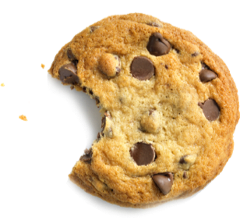

$\frac{1}{2}$ cup butter, softened
2 $\frac{1}{2}$ cups white sugar
1 cup packed brown sugar
2 eggs
2 teaspoons vanilla extract
$\frac{3}{4}$ cup all-purpose flour
1 teaspoon baking soda
2 teaspoons hot water
$\frac{1}{2}$ teaspoon salt
$\frac{1}{5}$ cups semisweet chocolate chips

